Software Development Unit 33, 2.1-2.5

Anna Legaspi

# 2.1 I can plan using suitable project management techniques

The project was to be conducted in the Agile way as well in a SCRUM framework. The task allocated was for each learner to create their own webpage and combine this so in the end, we have one website that holds everyone’s webpages. Once the webpage was completed, we also needed to test our website. It was understood that we were only going to be able to complete 1 sprint due to the time restrictions, so the idea was to be able to demonstrate agile methods within the 5-day duration.

Here is a list of broken-down tasks we’ve allocated to ourselves with the goal of delivering a website at the end of the sprint.

|  |  |  |
| --- | --- | --- |
| **Task** | **Owner** | **Deadline** |
| Create Trello board | Anna | Day 1 |
| Create and finalise Gantt chart | Keith | Day 3 |
| Create individual webpage | Everyone | Day 3 |
| Create main website template HTML and add everyone’s individual webpage | Anna | Day 3 |
| Create and finalise CSS style for website | Dan | Day 4 |
| Create testing spreadsheet | Anna | Day 4 |
| Test website | Everyone | Day 5 |
| Update Trello board until end of project | Everyone | Day 5 |

To be able to monitor the work efficiently and transparently by the whole team, we’ve setup a Trello Kanban board that is accessible by everyone. In addition, we’ve also completed a Gantt chart that we refer to which confirms whether we are delayed or in time. (Please see separate file with evidence of this)

This is our first time planning and creating a project as a team, so therefore the deadlines stated above wasn’t finalised on the first day. It took us until Day 2/3 until I was absolutely comfortable with the planning of the project. This was down to the following issues:

1. Not everyone was present on day 1 or day 2 of the project.
2. Not everyone had the time to complete their website straight away.
3. There were some alterations needed on people’s individual webpages to make things simpler in integrating all of it in one website.

# 2.2 I can apply appropriate project management techniques

For our project, we have decided to use Agile/Scrum techniques in collaboration with using the Kanban board. The product owner (Shafiq) has instructed that what he wanted each learner to create their individual webpages and for us to collaborate and have that each webpage is within one main website.

The tasks for this were broken down as per table above, and in the ‘Planning’ stage of the sprint, this was allocated to the team members (developers). Once it was allocated, team members added their task to the Kanban board to ensure that all tasks are in the list and not forgotten.

In this project, I’ve somehow been dubbed as the leader (Scrum master) and I’ve had emails from several team members asking for assistance. (See evidence). Every day, we had a virtual ‘Stand up’ meeting where we discuss and update each other about our tasks. I tend to start the meeting off by confirming which webpages were still outstanding, and I make sure that I address any communication I’ve received via email to everyone in the team. I also reconfirm the deadlines and ask if everyone is still on track with their work. Once the initial short update is discussed, we then start discussing major issues that we’ve encountered within the project.

During the development stage, we have also come across a few problems which I’ll itemise below.

## Simple web page & delays

One of the things that came to light was the fact that some people have submitted a full website with their own navigation instead of a basic webpage. With this in mind, I raised a point that if this were to be the case, I can link their website from the team’s website, but it will not be uniform with everyone else. In the interest of keeping things simple, everyone agreed to amend or create their webpage using simple HTML. We discussed that all that is needed is a simple image and a few paragraphs and no or limited CSS. Majority of the team has adhered to this, but there were still some members of the team that didn’t submit their page or still submitted a complicated webpage. The team member that submitted a complicated webpage was also late; therefore, their webpage was not fully integrated within the main website. The delay and inability to follow instructions of one team member has contributed to a defect within the website.

## Font issue

The choice of font I’ve used, Amatic, is not compatible with Firefox and Safari. This was an issue we found just before testing.

## CSS issue

A CSS effect on image overlay was added to the website. For some reason, doing this affected the position of the footer in some pages. At the same time, not all image overlay was working as expected as the size of the overlay was not the same as the image.

## Accessibility

The navigation buttons do not have the ‘alt’ attribute

## Code validation error

Most websites have code validation errors

It is expected to have problems throughout the project development stage and that is the reason why sprints exist. If we were given the opportunity to continue this project, we would tackle the issues I’ve noted above in the next sprint and it will be covered in the planning stage, reallocated and fixed.

# 2.3 I can use a range of tools and techniques in the recommended way

I’ve updated the tasks I needed to complete in the Trello Kanban board. During the project, I move the task along the board between ‘To do’, ‘Doing’, ‘Done’, ‘Testing’ and ‘Deploy’. (see evidence on Kanban)

I’ve also created a blank spreadsheet for the Gantt chart for everyone to view and for Keith to update. (see evidence on Gantt)

# 2.4 I can use and apply industry standard testing regimes and (describe) project management techniques

We’ve completed Manual testing as a group. I’ve volunteered to create the testing script for everyone to use. I did say that the test was kept high level and not too detailed for the purposes of saving time. The spreadsheet was created with the following columns:

1. Page (web) – to determine which page the step is to be done on
2. Action – what the tester needs to check or do
3. Expected result – what the result should be
4. Actual result – what the result is
5. Status (Pass, fail, out of scope) – if the step has passed, failed or out of scope.
6. Comments – any additional comments from the tester

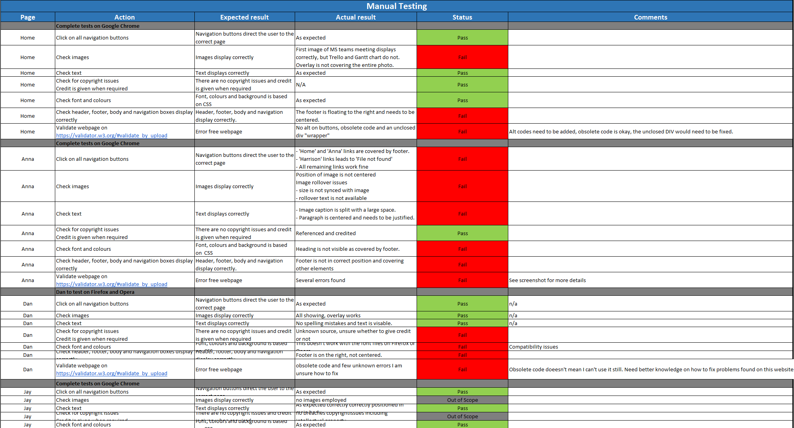

The agreement within my team is that we will test our own webpage since we knew exactly how we want the body of our webpage to display. Looking at the final test, I can see that some of the testing was done incorrectly. For example, I know that Harrison’s webpage doesn’t link correctly from any of the navigation buttons. Despite this, most testers have passed the step covering all navigation buttons on their webpage. Also, Harrison has passed his whole page despite the fact that it couldn’t be accessed at all from anywhere in the website.

I wasn’t present in our last meeting, so I’ve asked Dan to pass the message on to the rest of the team on my behalf.

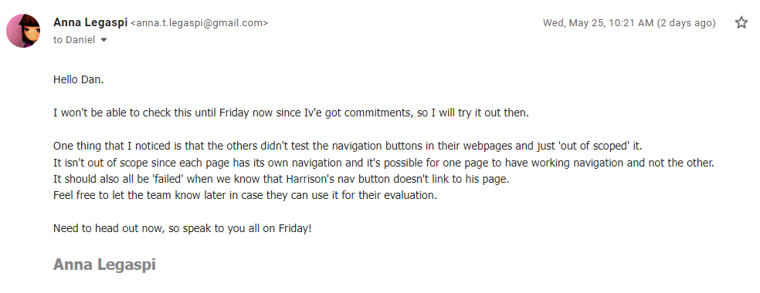

# 2.5 I can complete development tasks in a timely manner

We were first given 3 days to complete the website with testing as a group. On the first day of planning as a group, it became apparent it wasn’t going to be possible to complete all the work within the allocated time. We then asked our tutor, Shafiq, if the deadline can be extended to 5 days instead of 3.

From the tasks I’ve agreed to do, I’ve been able to complete all the tasks on time. I was able to complete the HTML and part of the CSS (It came from one of my pre-existing templates) by Day 2. I was also able to create the testing spreadsheet by Day 3.

Unfortunately, I couldn’t complete the website completely since I was waiting for other people to complete their individual website. Everyone sent me their website on time apart from Harrison who sent it on Day 4 and Adbulkabir who never did. This meant that the quality of the website was affected due these delays. This goes to show that everyone in the team needs to have accountability for their actions as it could be a detriment to the overall project.